# Part A Normalized Model

## 1a First Normal Form

### Table Design



CREATE TABLE [dbo].[Sales_1NF]

(

[Id] INT NOT NULL IDENTITY(1,1),

[OrderId] INT NOT NULL,

[DonutId] INT NOT NULL,

[Name] NVARCHAR(50) NOT NULL,

[Description] NVARCHAR(250) NULL,

[UnitPrice] MONEY NULL,

[Quantity] INT NOT NULL,

[SaleDate] DATE NOT NULL,

[SpecialHandlingNotes] NVARCHAR(500) NULL,

[CustomerId] INT NULL,

[CustomerFirstName] NVARCHAR(50) NULL,

[CustomerLastName] NVARCHAR(50) NULL,

[CustomerStreetAddress1] NVARCHAR(50) NULL,

[CustomerStreetAddress2] NVARCHAR(50) NULL,

[CustomerCity] NVARCHAR(50) NULL,

[CustomerState] NCHAR(2) NULL,

[CustomerZip] NCHAR(6) NULL,

[CustomerHomePhone] NCHAR(10) NULL,

[CustomerMobilePhone] NCHAR(10) NULL,

[CustomerOtherPhone] NCHAR(10) NULL,

CONSTRAINT [PK_Sales_1NF] PRIMARY KEY (Id)

)

### Reasoning

I took the Sales form sheet and reviewed the data to break out each individual artifact. The table has been broken up based on the requirements and the unique data points found within the form. From there I used a standard naming convention to give each data point a self describing name like, CustomerFirstName, to make a clear designation on the type of value one could find in the column. Each data point was also examined to determine what type of data it best represented. A whole number such as id or count column was assigned as an integer, any short text string stored as nchar, longer text strings stored as nvarchar, and then money for the unit price.

## 1b Second Normal Form

### Table Design



CREATE TABLE [dbo].[Customer_2NF]

(

[CustomerId] INT NOT NULL IDENTITY(1,1),

[LastName] NVARCHAR(50) NOT NULL,

[FirstName] NVARCHAR(50) NOT NULL,

[MiddleName] NVARCHAR(50) NULL,

[Address1] NVARCHAR(250) NOT NULL,

[Address2] NVARCHAR(250) NULL,

[City] NVARCHAR(50) NOT NULL,

[State] NCHAR(2) NOT NULL,

[Zip] NCHAR(6) NOT NULL,

[CustomerHomePhone] NCHAR(10) NULL,

[CustomerMobilePhone] NCHAR(10) NULL,

[CustomerOtherPhone] NCHAR(10) NULL,

CONSTRAINT [PK_Customer_2NF] PRIMARY KEY (CustomerId)

)



CREATE TABLE [dbo].[Product_2NF]

(

[ProductId] INT NOT NULL IDENTITY(1,1),

[Name] NVARCHAR(50) NOT NULL,

[Description] NVARCHAR(250) NOT NULL,

[UnitPrice] MONEY NOT NULL,

CONSTRAINT [PK_Product_2NF] PRIMARY KEY (ProductId)

)



CREATE TABLE [dbo].[Sales_2NF]

(

[Id] INT NOT NULL IDENTITY(1,1),

[OrderId] INT NOT NULL,

[SaleDate] DATE NOT NULL,

[CustomerId] INT NOT NULL,

[ProductId] INT NOT NULL,

[Quantity] INT NOT NULL,

[SpecialHandlingNotes] NVARCHAR(500) NULL,

CONSTRAINT [PK_Sales_2NF] PRIMARY KEY (Id),

CONSTRAINT [FK_Sales_Customer] FOREIGN KEY ([CustomerId]) REFERENCES [Customer_2NF]([CustomerId]),

CONSTRAINT [FK_Sales_Product] FOREIGN KEY ([ProductId]) REFERENCES [Product_2NF]([ProductId])

)

### Reasoning

The sales data was broken out to 3 sections. Product data to store the information into each individual item that can be sold. This allows the sales table to track each instance and the quantity that a product has been sold. The Customer table stores each separate customer to be able to re-use the same data for each occurrence of a sales instance. The Sales table tracks information specific to each transaction along with the individual components of the sales data. The current sales data still allows for duplication of information because each unique product sold on that sale requires a row. This will duplicate the OrderId, CustomerId, SaleDate, and the Special Handling Notes. Foreign Key constraints were added to require valid products and customers to be linked to a sales record.

## 1c Third Normal Form

### Table Design



CREATE TABLE [dbo].[Customer_3NF]

(

[CustomerId] INT NOT NULL IDENTITY(1,1),

[LastName] NVARCHAR(50) NOT NULL,

[FirstName] NVARCHAR(50) NOT NULL,

[MiddleName] NVARCHAR(50) NULL,

[Address1] NVARCHAR(250) NOT NULL,

[Address2] NVARCHAR(250) NULL,

[City] NVARCHAR(50) NOT NULL,

[State] NCHAR(2) NOT NULL,

[Zip] NCHAR(6) NOT NULL,

[CustomerHomePhone] NCHAR(10) NULL,

[CustomerMobilePhone] NCHAR(10) NULL,

[CustomerOtherPhone] NCHAR(10) NULL,

CONSTRAINT [PK_Customer_3NF] PRIMARY KEY (CustomerId)

)



CREATE TABLE [dbo].[Product_3NF]

(

[ProductId] INT NOT NULL IDENTITY(1,1),

[Name] NVARCHAR(50) NOT NULL,

[Description] NVARCHAR(250) NOT NULL,

[UnitPrice] MONEY NOT NULL,

CONSTRAINT [PK_Product_3NF] PRIMARY KEY (ProductId)

)



CREATE TABLE [dbo].[Sales_3NF]

(

[Id] INT NOT NULL IDENTITY(1,1),

[OrderId] INT NOT NULL,

[SaleDate] DATE NOT NULL,

[CustomerId] INT NOT NULL,

[SpecialHandlingNotes] NVARCHAR(500) NULL,

CONSTRAINT [PK_Sales_3NF] PRIMARY KEY (Id),

CONSTRAINT [FK_Sales_Customer_3] FOREIGN KEY ([CustomerId]) REFERENCES [Customer_3NF]([CustomerId]),

)



CREATE TABLE [dbo].[Line_Item_3NF]

(

[Id] INT NOT NULL IDENTITY(1,1),

[OrderId] INT NOT NULL,

[ProductId] INT NOT NULL,

[Quantity] INT NOT NULL

CONSTRAINT [PK_Line_3NF] PRIMARY KEY (Id),

CONSTRAINT [FK_Line_Product_3NF] FOREIGN KEY ([ProductId]) REFERENCES [Product_3NF]([ProductId]),

CONSTRAINT [FK_Line_Sales_3NF] FOREIGN KEY ([OrderId]) REFERENCES [Sales_3NF]([Id])

)

### Reasoning

Most of the tables in this form are nearly the same as the second normal form. However, in the third normal form we have added an additional table called Line Item. This table breaks out the line item information that pertains to a sale to its own table. This allows the main Sales table to contain one row about the sale itself. No longer will there be multiple entries for the order number, sale date for that order, customer id for the order, or special handling notes. The Line Item table contains a foreign key constraint against the order table to only allow actual order records to be linked to a line item. It also contains a foreign key constraint against the product table to ensure we have only valid products linked to an order.

# Part B Entity Relationship Diagram

## Diagram



## Explanation

The entities in my diagram are as requested in the requirements. It includes 4 tables which are the Customer table, Product table, Sales table, and Line Item table. The customer table is linked to the sales table as per the order form there is only one customer per order. This establishes a one-to-many relationship between customers and sales. A sale will contain 1 or more products sold. The products are stored in the line item table. As a sale can have multiple products and products can be linked to multiple sales, this establishes a many-to-many relationship between sales and line items. Finally we have the Product table which is tied to the line items. There can only be one instance of a donut in the product table, but that donut can be ordered many times in the line item table which indicates a one-to-many relationship between products and line items.

# Part C Proof of Compiling

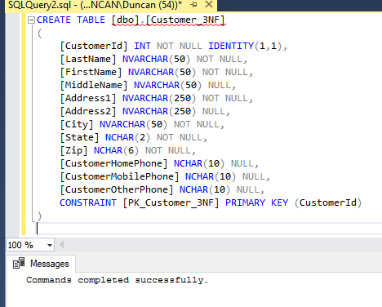

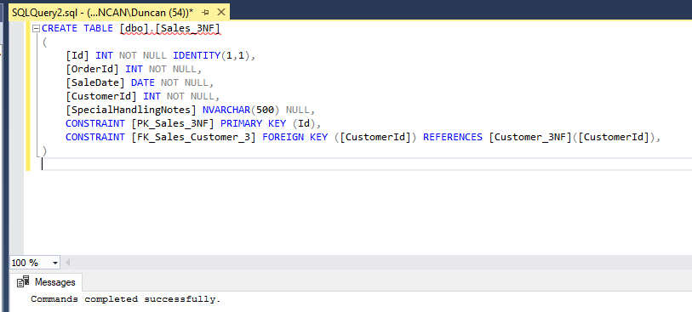

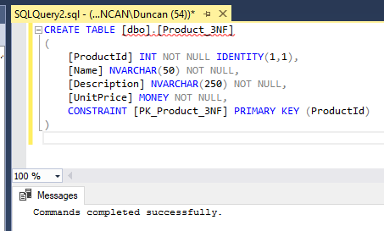

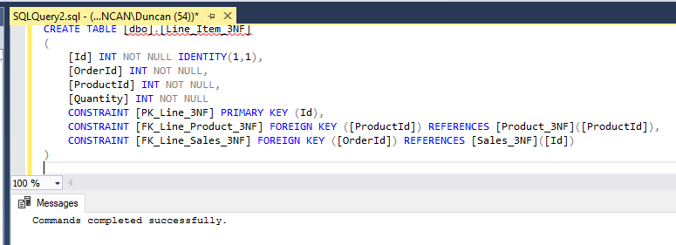

# Part D Customer View

## SQL Code

CREATE VIEW [dbo].[vw_Customer] AS

SELECT CONCAT(FirstName, ' ', LastName) AS Name, LastName, Firstname, MiddleName, Address1, Address2, City, State, Zip, CustomerHomePhone, CustomerMobilePhone, CustomerOtherPhone

FROM [Customer_3NF]

## Screenshot Proof

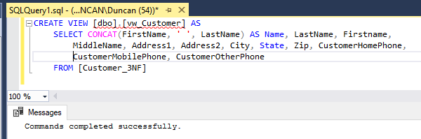

# Part E Create Product Name Index

## SQL Code

CREATE INDEX [IDX_ProductName]

ON [dbo].[Product_3NF]

(Name)

## Screenshot Proof

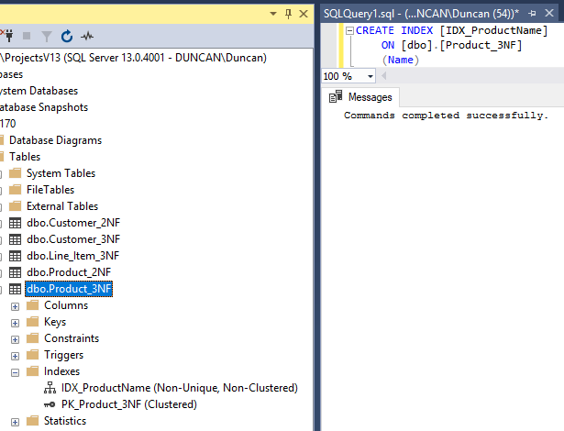

# Part F Populate Tables

## SQL Code

DECLARE @customerId int;

DECLARE @productId int;

DECLARE @saleId int;

INSERT INTO Customer_3NF (LastName, FirstName, MiddleName, Address1, Address2,

City, Zip, State, CustomerHomePhone, CustomerMobilePhone, CustomerOtherPhone)

VALUES (

'Nisbett', 'Duncan', 'Edward', '123 Main Street', 'Apt #B4',

'Denver', '49123', 'CO', '5551234567','5553219966','5559876543'

);

SELECT @customerId = SCOPE_IDENTITY();

INSERT INTO Product_3NF (Name, Description, UnitPrice)

VALUES (

'Glazed', 'Glazed Donut', 1.75

);

SELECT @productId = SCOPE_IDENTITY();

INSERT INTO Sales_3NF (OrderId, SaleDate, CustomerId, SpecialHandlingNotes)

VALUES (

456, GetDate(), @customerId, 'Please include plates and napkins.'

);

SELECT @saleId = SCOPE_IDENTITY();

INSERT INTO Line_Item_3NF (OrderId, ProductId, Quantity)

VALUES (

@saleId, @productId, 5

);

## Screenshot Proof

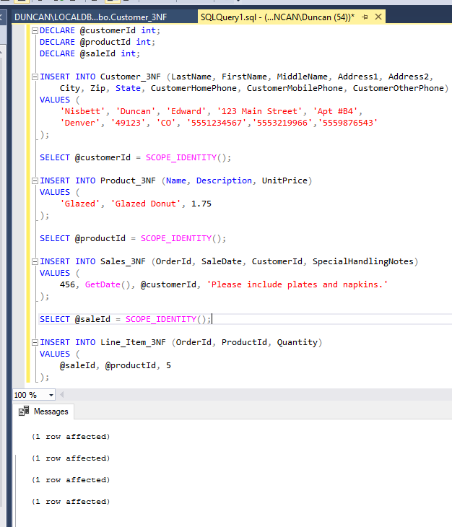

# Part G Display Values and Complex Join

## Queries

SELECT * FROM Customer_3NF;

SELECT * FROM Product_3NF;

SELECT * FROM Sales_3NF;

SELECT * FROM Line_Item_3NF;

## Screenshot Proof

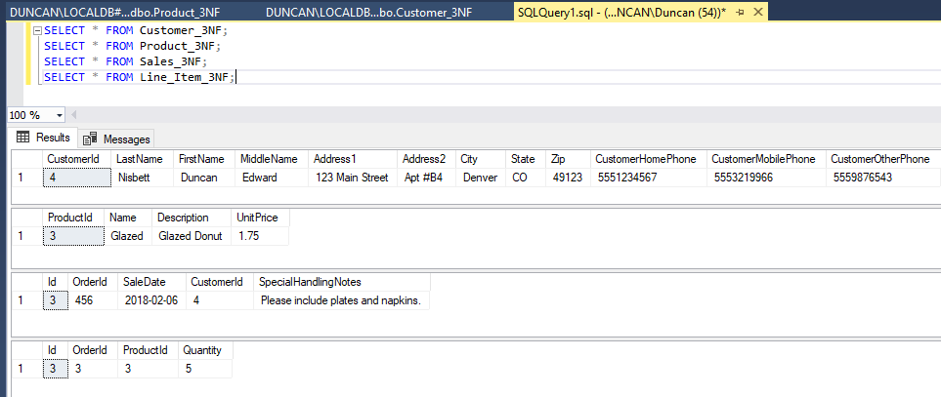

## Complex Join SQL

SELECT *

FROM Line_Item_3NF l

INNER JOIN Product_3NF p ON p.ProductId = l.ProductId

INNER JOIN Sales_3NF s ON s.id = l.OrderId

INNER JOIN Customer_3NF c ON c.CustomerId = s.CustomerId

## Complex Join Screenshot

